
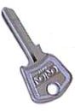
PRAVDA
THE TRUTH of KEY CLUB


Editors Desk
"...Just because you express yourself differently and give the raw facts, society goes around and labels you as a punk!" –Dureid Khamo

Welcome to the desk of you’re friendly neighborhood dictator, Evan Marks! We at Pravda work long and hard to bring you the exceptional Key Club coverage that you want and deserve. From what started as a rag-tag group of bored editors, Pravda has grown and flourished to become one of Escondido High’s top Key Club bulletins. And however much I would like to say that that is entirely my doing, I am unable to do so. We have only reached this point because of you, dear reader. If not for your fanatic dedication, we would still be in the back of my garage, building bombs. And for that reader, I am sure the whole world thanks you. That, my friends, is the TRUTH.

Thanks,
KEY CLUB PLEDGE

I pledge on my honor,
To uphold the objects of Key Club International;
To build my home, school, and community,
To serve my nation and God,
And to combat all forces which tend
To undermine these institutions !!

Evan Marks

DCM

There’s nothing like family togetherness, and here at Key Club, we love getting together with our fellow schools. Unlike the bloody feuds held by football fans, we key clubbers of separate schools treat one another like distant cousins. Nothing brings about this family togetherness like a monthly district convention meeting. Key Clubbers from all of division 37 south met at a Soup(p)lantation last Saturday to discuss the past and upcoming months. Key Clubbers also were able to meet Lt. Governor, Ashley Grand, which was really cool (I got her signature!!). In the back of the none-to-crowded restaurant, key clubbers listened to Ashley as she went over some of our upcoming projects and events, following the “COLOR the earth” and “Four Seasons of Service” themes. Also introduced were the new 2004-2005 divisional officers, Ashley Gisiger for Ex. Assistant, and Hayley Sher as Divisional Secretary. Both seemed to be good applicants for the job, and should assist our Lt. Governor very well. Also brought up was the need for a new T-Shirt design, which I can say has got me thinking about some very cool ideas for our key club clothing. Ashley also passed out her very own district bulletin, “The Bull Sheet.” Don’t let the title fool you though, for it was very interesting and well done, and I could find nothing that I would consider to be “bull” in it. More importantly though, Escondido, out Club were acknowledged many times in the bulletin, from the La Jolla Half Marathon to Abby’s incredible cute stories. It is obvious, it seems, that Escondido is rising to the top thanks to me-er, I mean, our outstanding membership. And that is the TRUTH.

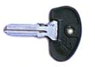
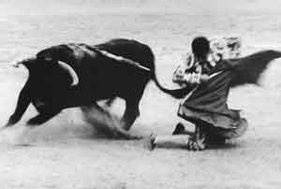
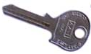

Questions? Comments?
Concerns? I’m no president, but try calling one!!

Phone- (760) 741-5309

AIM- CougarKeyClub

The Bulls

