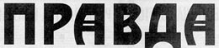
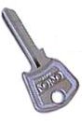
PRAVDA
THE TRUTH of KEY CLUB

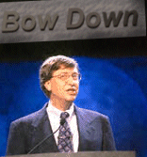
Editors Desk
“Sometimes I get the feeling the whole world is against me, but deep down I know that's not true. Some smaller countries are neutral.”
It’s that time again! Summer is almost here, and that sweet, sweet smell of finals is in the air. But while you people are thinking of all the fun you’re going to be having in summer school, we at Pravda are crying, yes crying; like the girly men we are. For with summer comes the end of the school year, and with that comes the end of Key Club meetings. With no meetings, there can be no Pravda, and with no Pravda, we who work here will be forced to put all of our attention back into building plastic explosives and attempting to bring down the evil regimes that rule our world today. But to all you fellow key clubbers, don’t dismay, we have plenty for you to do over the summer. So dear reader, try to have a wonderful summer without us, we know it’s hard.

That my friends, is the TRUTH,
Evan Marks
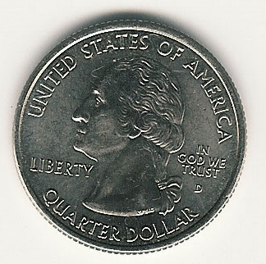
KEY CLUB PLEDGE

I pledge on my honor,
To uphold the objects of Key Club International;
To build my home, school, and community,
To serve my nation and God,
And to combat all forces which tend
To undermine these institutions !!

The Miracle Mile of Quarters
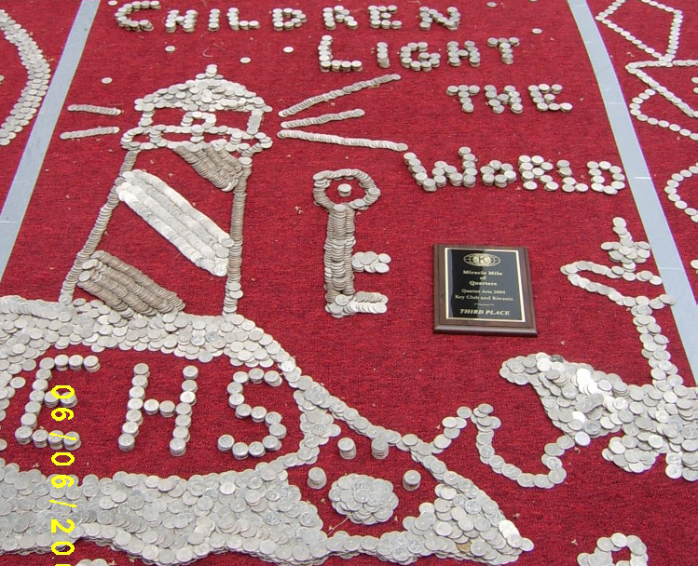
Last Sunday, Key Clubs from across California met in front of Children’s Hospital to help display the outcome of the quarter donation that had been taking place. Thousands of quarters were used by every school’s club to help create a magnificent work of art that not only looked good, but was worth a lot of money. These various quarter arrangements were set up on a mile long stretch of red carpet, divided evenly for the numerous schools present. Awards were then given for the best-of-the-best, our school winning third place, a much deserving position to be sure. Here you can see our fabulous work of art that puts even Picasso to shame (take special notice to the boat in the lower corner). If you look closely, you can see our award right there in the center. Good stuff.
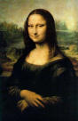
After we finished decorating out stretch of carpet, I took the liberty to use some of the extra quarters we had left to create these two simple designs:

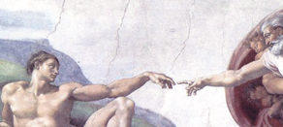

They’re not all that great, but hey, I only had a few minutes. I especially like the one on the right; I call it, “God giving life to Key Club.” Let me tell you, getting skin tones with quarters is HARD. I figured that by melting the quarters at just the right angle, I could get it to look decent enough however. The photo to the left is of my other design, which I must say, was a total disaster. I mean, just look at the eyes, they’re totally messed up. Also, it took forever to angle each quarter so that it looked as if she was wearing a black dress. The judges didn’t like either I suppose, as neither one won anything important, although I did win the “best-use-of-tilting-the-quarters-award” for the picture of the lady, which I called “Moma Liza.” All in all, the entire event was great fun, with various radio and T.V. stations there for support, as well as free food. Hopefully more people will show up next year, seeing as I have some great ideas for a 3-D model. And I swear that’s the TRUTH.
God giving Life to Key Club
Moma Liza

