
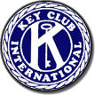
PRAVDA
THE TRUTH of KEY CLUB


Editor’s Desk
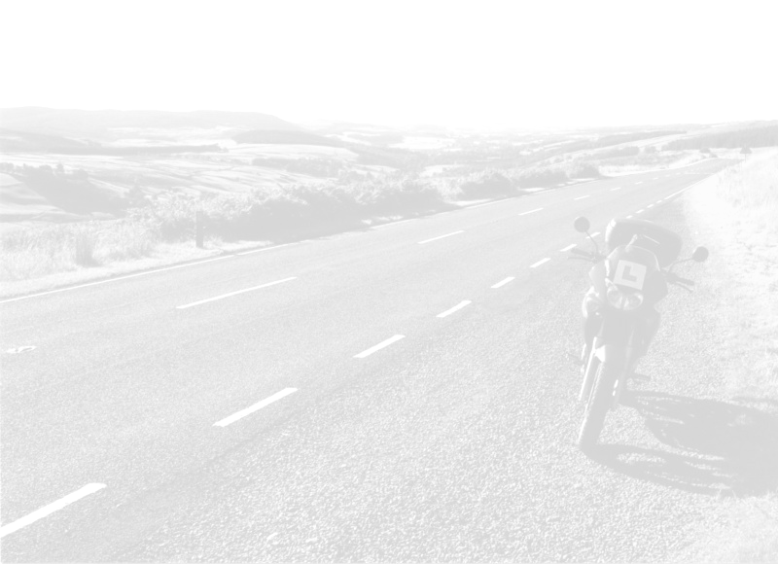
Dang! Time for another newsletter already? I guess my three week vacation to the Caribbean will just have to wait. Oh well. But seriously, I love writing these things. In fact, someday I hope to get people to actually read them. You know, instead of just blow their nose with it, or use it as a cheap substitute for toilet paper. Hmmm…I might just have something there... “Pravda: The Truth of Key Club, now softer then ever!” And that’s the truth. Really, it is.

Sincearaley,
Evan Marks
KEY CLUB PLEDGE

I pledge on my honor,
To uphold the objects of Key Club International;
To build my home, school, and community,
To serve my nation and God,
And to combat all forces which tend
To undermine these institutions !!

Highway Cleanup

Ah, the Highway. Sometimes a perfect symbol for this country’s freedom; other times a nasty mess of angry drivers and stopped cars. Either way however, it manages to get really, really dirty. So last Saturday, October 2, several enthusiastic Key Clubbers decided to wake up insanely early in order to pick up trash on the freeway. In fact, it was the largest showing of Key Clubbers to a Highway (freeway, whatever) Cleanup as of yet. Which, as great as that is, caused a great deal of space to be taken up in the vehicles, and rather odd seating arrangements. But we managed to pull through. Or some of us did. The stronger ones.
Anyway, I am sure that for those of you who have never been to a Highway Cleanup are dying to hear what it’s all about; or at least wondering a little. Well, basically we wake up really early, eat lard-fried donuts (mmm…), divide into groups, and clean up our assigned sections of Freeway (highway, whatever) for an hour or so. If you ask me, it’s a great way to start the weekend, and it does feel pretty good to know that by cleaning up the freeway you could save a whale’s life somewhere. Or was that a lion’s? Koala?
Probably the best thing about Highway Cleanup however, is the cool stuff you find. I mean, check out all this stuff I found:

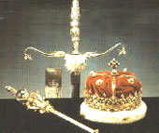

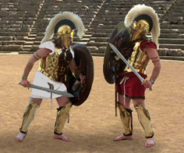
As you can see I found some pretty interesting things. Like those jewels, which I found under a bush somewhere. I had them cleaned and polished, and then sold them to the U.K. on Ebay. Made a bundle. That other picture is of the box of Trojans I found (what? Trojan soldiers!). Those were pretty cool too. I ended up throwing them away though, they were kind of used (battle-worn, you know). All in all the Highway Cleanup was really fun, and you don’t want to miss out again if you didn’t make it.

Highway Cleanup! Don’t miss it! Go to the Friday meetings to find out when the next one is.

