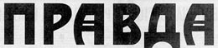
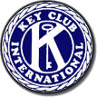

PRAVDA
THE EMPIRE
THE TRUTH of KEY CLUB

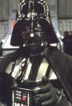
Emperor’s Desk

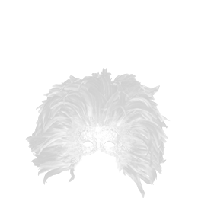
After this newsletter’s past editor failed to reveal the position of the rebel base, I was forced to have him….removed. I am taking advantage of this obviously widely-read newsletter to remind citizens of this planet that failure to yield to the Emperor’s might will only lead to your planet’s destruction. Never underestimate the power of the dark side. I sense that readers might also wish to read of this “key club” that this newsletter is so avid towards. In order to attend to this I will require total devotion to the Empire from this planet. Anything otherwise will only lead you to your doom.

You will join us or die,
Darth Vader
KEY CLUB CLUB PLEDGE

I pledge on my honor,
To uphold the objects of Key Club International;
To build my home, school, and community,
To serve my nation and God,
And to combat all forces which tend
To undermine these institutions !!

The Midnight Mask-er-aid

Hey fellow Key-Clubites! Mr. Vader here allowed me out of my cell for a few moments to write this article. He’s really quite nice once you get to know him actually. I only have a few seconds so I’ll have to get right to it.
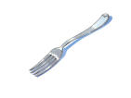
Last Saturday, several Key Clubbers went downtown to the Center for the Arts where we helped set-up the “Midnight Mask-er-aid.” We arrived a little before noon, hoping a fairly easy next few hours. We were wrong.
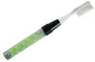
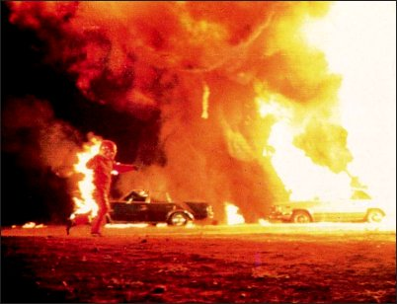
For our first task we were asked to sweep up the leaves around the fountain. Easy enough; until we were given our sweeping tool. That’s right, a toothbrush. It wasn’t even electric either. Abby’s was even slightly used. Being the good Key Clubbers that we are however, we accepted our work without complaint, and begin sweeping, er…brushing. We managed to get several bags full after three hours, though it was hard to pick up the leaf piles with a plastic fork (our other tool).
Everything was going fairly well, right until we were about to finish our brushing, when Bekah took a wrong turn and tripped into a pile of leaves. Or, at least, that’s what we thought it was, when it reality it was a bag full of nitro-glycerin that someone had left out from the last clean-up. She escaped the flaming inferno nearly unharmed however, though did a need a band-aid for her finger. The entire west- section of the Center for the Arts was not so lucky.
Well, here comes the torture droid! That’s my queue to leave. Farewell dear readers!
And that’s the tru- *ZAP* ouch! Uh oh…

