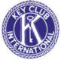
… назад …

The True Story of
Thanksgiving

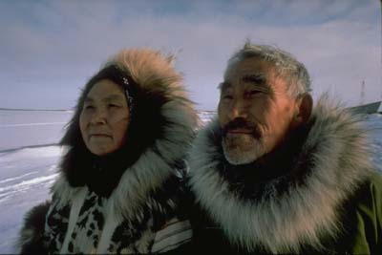
I’m sure you’ve all heard the legendary tale of how Marco Columbus invented America in 1842, and of the legendary feast creating a last friendship between the Germans and the Eskimo tribes of America. But, have you ever heard the story of Kiwa, the Eskimo who saved thanksgiving? No, you haven’t. Unless this is the second time you’re reading this.
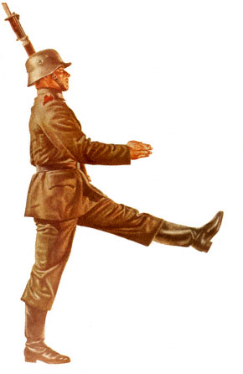
When the Germans first landed on America, it was in the cold of November. Unfortunately the Germans had only packed microwave dinners, in the hope that there would be an abundance of microwaves in the new land. They were dreadfully wrong. And with the ensuing winter, dreadfully hungry. The Eskimos of America took pity on the poor Germans and wanted to invite them to dinner. Unfortunately, as everyone knows, Eskimos make terrible organizers. And as any host knows, it requires a great deal of organizationatory skills to organize something as complex as a dinner.
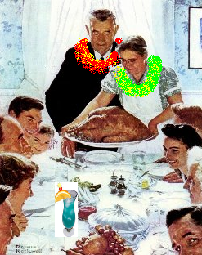
Lucky for them Kiwa wasn’t like other Eskimos. While they were out having fun and arresting Indians, Kiwa was filling out reports. When all the other Eskimos were out writing essays on transcendentalism, Kiwa was organizing them into books to be read by future generations of energetic high school students. And while all the other Eskimos were out making good money, Kiwa was organizing it into his own bank account with a 5% interest rate, compounded continuously. So it was up to Kiwa to organize a dinner between the Germans and the Eskimos that would create a lasting friendship for decades to come.
First he needed a theme. Hawaiian of course. Then he needed to organize a fundraiser to raise funds for this dinner. So he sold Westfield shopping tickets. He was hugely successful. Being the bright man that he was, he also organized a group of personal followers whom he called “Kiwanians” to help cook, pass out food, and then clean up after the dinner was over. They of course jumped up to the position.
His dinner was so successful that it became an annual event. And his followers went out around the world to spread the joys of community service, and just generally helping out. They adopted the name Kiwanis in honor of their great leader Kiwa and eventually educated their youth to the same in a program they called K.E.Y. Club or “Kool Extreme Yoga” Club.
By Allen Dunlea

