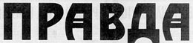
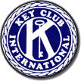
PRAVDA
THE TRUTH of KEY CLUB

The Escondido Christmas Parade


Editor’s Desk

Hello readers, and welcome to the ninth edition of Pravda: The Truth of Key Club! I had originally planned a fabulous new design for this weeks newsletter, seeing as I am learning how to use Microsoft Publisher at school. Too late did I realize that my computer at home is not equipped with such advanced technology as Publisher, and therefore my dreams were smashed, brutally. Publisher’s superior newsletter-creator did give me a few ideas for basic design however, so look closely and you might notice a few new things here and there. Otherwise, just read it, use it as tissue paper, burn it for fuel, or whatever you would normally do with it. I suggest reading it; unless of course you really need the warmth from the fire. And that’s the truth.

-Evan Marks

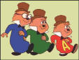
In what could be considered Escondido’s best Christmas Parade, the Escondido Christmas Parade dazzled hundreds of people last Saturday morning. Mixed in with the numerous floats, bands, and circus acts, was our very own Key Club float. Many of us had put our sweat and blood into the construction of that float, and it showed. In fact, on several occasions people were actually blinded by the float’s magnificence.
Alvin, Simon, and Theodore, in all of their magnificence and glory.

That put aside, our float was a huge success. People flocked for miles simply to touch the plywood cut-outs of Alvin, Simon, and Theodore. Reports flooded throughout the world that “a new Mecca had been discovered,” and that “the Messiah had returned in the form of a parade float.” Elderly women swore to be able to see visions of their dead relatives when near the float, and three people claimed to have been raised from the dead, have their vision restored, and be cured from leprosy, all at the same time.
Several floats were very elaborate. Here you can see a rendition of “Santa’s Sleigh,” created by local kindergarteners.
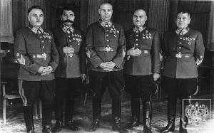

Yet even with our float’s otherworldly powers (something we had not planned it to have), the competition was fierce. A local kindergarten had created a mobile “Santa-launcher” out of cardboard and bullet-proof ceramic plating, able to fire armor piercing candy-canes at an incredible rate. Public appeal for their float took a turn for the worse however, when a misfire took out both Mr. and Mrs. Clause. The judges also argued that while candy-canes were in the Christmas spirit, explosive tipped ones were not.
A few of the “kindergarteners” in question.
Key Club Pledge

I pledge on my honor, to uphold the objectives of Key Club International, to build my home, school and community, to serve my nation and God, and to combat all forces which tend to undermine these institutions
All in all, the parade was a big success, and our float will definitely be up for some awards. Hopefully next year’s parade will be even better. That is, once again, the truth. And yes, have a very Merry {Insert desired Holiday here}!

